**Week 9 Session2- Lab**

**Question:-**

Create a Database & Table Using MySQL Command-Line Client.

● Create a database with the name StudentManagementSystem.

Create a table with named Student with attributes:

● StudentID (Primary Key)

● FirstName

● LastName

● DateOfBirth

● Gender

● Email

● Phone

Create a table with name Course with attributes:

● CourseID (Primary Key)

● CourseTitle

● Credits

Create a table with named Instructor with attributes:

● InstructorID (Primary Key)

● FirstName

● LastName

● Email

Create a table with named Enrollment with attributes:

● EnrollmentID (Primary Key)

● EnrollmentDate

● StudentID(Foreign key)

● CourseID(Foreign Key)

● InstructorID(Foreign key)

Create a table with named Score with attributes:

● ScoreID (Primary Key)

● CourseID (Foreign key)

● StudentID (Foreign Key)

● DateOfExam

● CreditObtained

Create a table with named Feedback with attributes:

● FeedbackID (Primary Key)

● StudentID (Foreign key)

● Date

● InstructorName

● Feedback

**Use the Database and table from Week9 Session1 lab. Insert 5 records and**

**retrieve data from the table.**

**Answers:-**

create database studentmanagementsystem;

use studentmanagementsystem;

CREATE TABLE Student (

StudentID VARCHAR(10) PRIMARY KEY,

FirstName VARCHAR(25),

LastName VARCHAR(25),

DateOfBirth DateTime,

Gender VARCHAR(25),

Email VARCHAR(30) UNIQUE,

Phone VARCHAR(25)

);

CREATE TABLE Course (

CourseID VARCHAR(10) PRIMARY KEY,

CourseTitle VARCHAR(30),

Credits INT

);

CREATE TABLE Instructor (

InstructorID VARCHAR(10) PRIMARY KEY,

Email VARCHAR(30) UNIQUE,

FirstName VARCHAR(30),

LastName VARCHAR(30)

);

CREATE TABLE Enrollment (

EnrollmentID VARCHAR(10) PRIMARY KEY,

EnrollmentDate DATE,

StudentID VARCHAR(10),

CourseID VARCHAR(10),

InstructorID VARCHAR(10),

FOREIGN KEY (StudentID) REFERENCES Student(StudentID),

FOREIGN KEY (CourseID) REFERENCES Course(CourseID),

FOREIGN KEY (InstructorID) REFERENCES Instructor(InstructorID)

);

CREATE TABLE Score(

ScoreID VARCHAR(10) PRIMARY KEY,

StudentID VARCHAR(10),

CourseID VARCHAR(10),

FOREIGN KEY (StudentID) REFERENCES Student(StudentID),

FOREIGN KEY (CourseID) REFERENCES Course(CourseID),

CreditObtained VARCHAR(10),

DateOfExam DateTime

);

CREATE TABLE Feedback(

FeedbackID INT Auto_Increment PRIMARY KEY,

StudentID VARCHAR(10),

Date DATE,

InstructorName VARCHAR(30),

Feedback VARCHAR(100),

FOREIGN KEY (StudentID) REFERENCES Student(StudentID)

);

INSERT INTO Student (StudentID,FirstName,LastName,DateOfBirth,Gender,

Email,Phone) VALUES

('S101','John', 'Doe','2000-10-10','M', 'john@example.com','9878457945'),

('S102','Jane', 'Smith','2013-08-08','M', 'jane@example.com','9977457745'),

('S103','Alice', 'Johnson','2011-09-08','F', 'alice@example.com','9876457845'),

('S104','Anna', 'Doe','2011-07-08','F', 'Anna.doe@india.com','9876457842'),

('S105','Peter', 'Parker','2011-06-05','M', 'p_parker@example.com','9276457843');

SELECT * FROM Student;

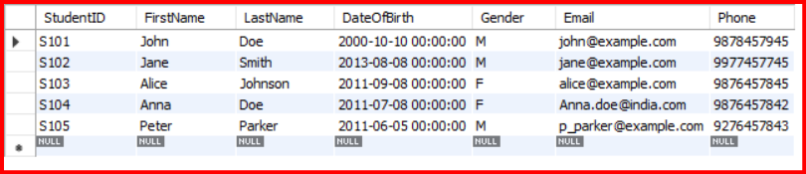

Select FirstName from Student;

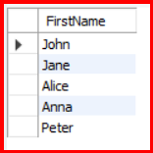

INSERT INTO Course (CourseID,CourseTitle,Credits) VALUES

('C101','Math101',12),

('C102','History101',13),

('C103','Computer Science101',11);

SELECT * FROM Course;

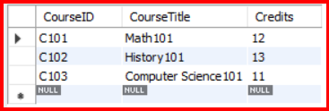

INSERT INTO Instructor (InstructorID ,Email,FirstName,LastName) VALUES

('I101','sunil@example.com','Sunil','Rawat'),

('I102','nida@example.com','Nida','Fatima'),

('I103','shiv@example.com','Shiv','Kumar');

SELECT * FROM Instructor;

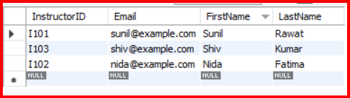

INSERT INTO Enrollment (EnrollmentID, EnrollmentDate, StudentID, CourseID, InstructorID) VALUES

('E1001', '2023-08-28', 'S101', 'C101', 'I101'),

('E1002', '2023-08-18', 'S102', 'C101', 'I101'),

('E1003', '2023-08-25', 'S103', 'C102', 'I102');

SELECT * FROM Enrollment;

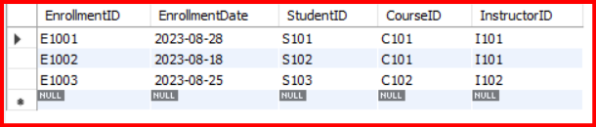

INSERT INTO Score

(ScoreID,StudentID,CourseID,CreditObtained,DateOfExam)VALUES

('SC101','S101','C101','12','2022-10-10'),

('SC102','S102','C101','10','2022-10-10');

SELECT * FROM Score;

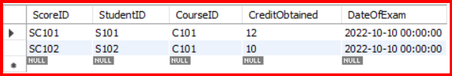

INSERT INTO Feedback(StudentID, Date, InstructorName, Feedback) VALUES

('S101', '2023-08-18', 'I101', 'Session was good'),

('S102', '2024-01-20', 'I101', 'Topic was well explained'),

('S103', '2023-10-29', 'I102', 'Session was excellent');

SELECT * FROM Feedback;

